Guide to Enrolling in the IRB001 Course on Canvas

- Navigate to Canvas: https://www.nus.edu.sg/canvas/login/. Login with your student/ staff NUS account:

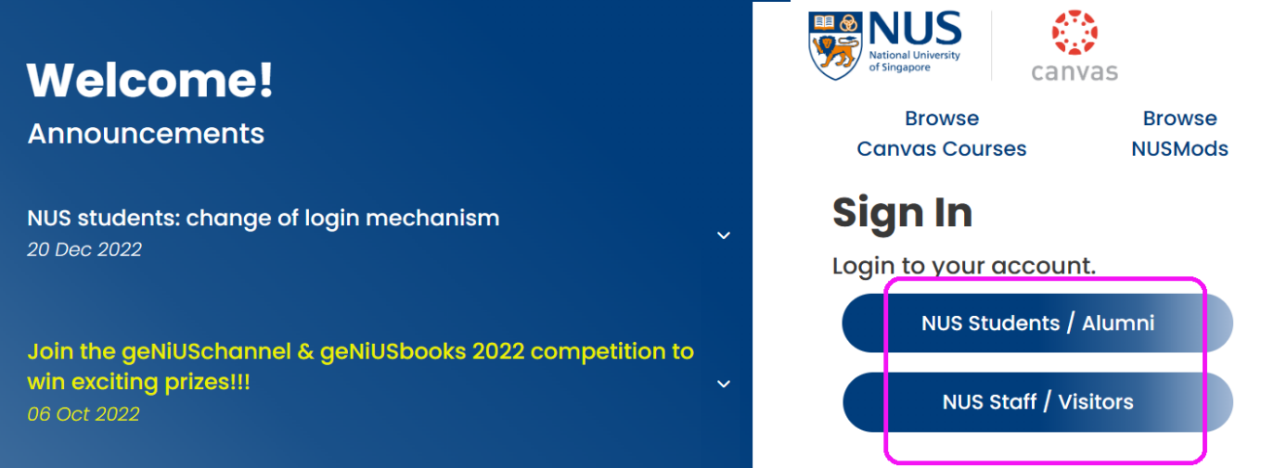

- On the left panel, select Courses – All Courses:

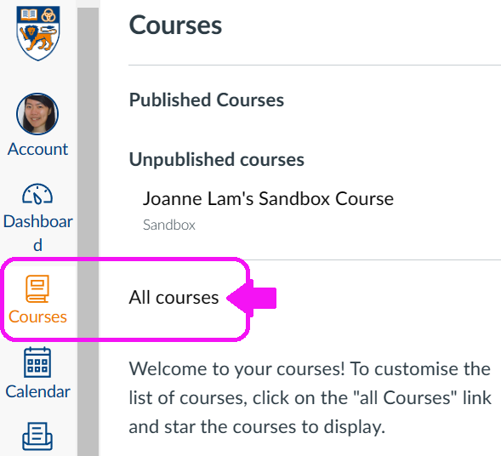

- Select 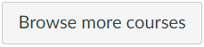 – Type IRB as the Course Name. And then click Search.
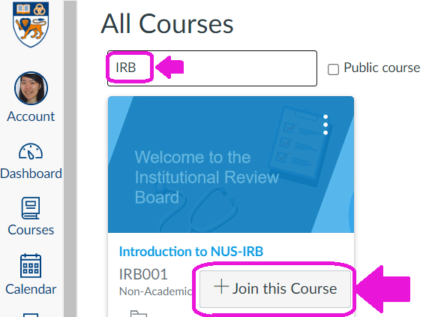

- Under Introduction to NUS-IRB, click + Join this Course. This will take you to the Course Homepage. Please view the short videos and complete the quizzes (approx. 40 mins).

